1. **Diagrama de Casos de Uso**



1. **Realización de Casos de Uso**



1. **Diagrama de Arquitectura**

Datos

Modelo

Proceso

1. **Diagrama de Componentes**



1. **Diagrama de Clases**

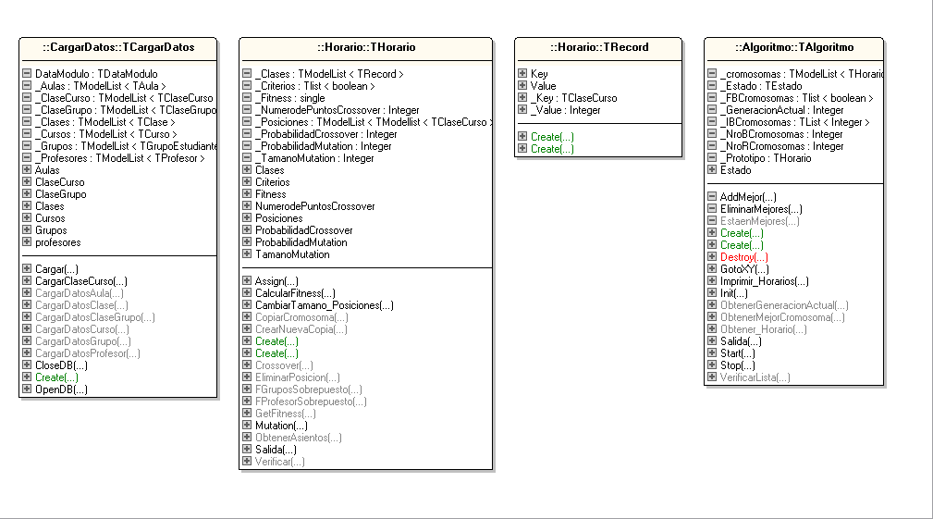

**Package: CargarDatos**

|  |  |
| --- | --- |
| **TCargarDatos** | **class** |

**Attributes**

|  |  |  |
| --- | --- | --- |
| **Name** | **Type** | **Visibility** |
| _Aulas | TModelList ( TAula ) | private |
| _Cursos | TModelList ( TCurso ) | private |
| _Clases | TModelList ( TClase ) | private |
| _Grupos | TModelList ( TGrupoEstudiante ) | private |
| _Profesores | TModelList ( TProfesor ) | private |
| _ClaseGrupo | TModelList ( TClaseGrupo ) | private |
| _ClaseCurso | TModelList ( TClaseCurso ) | private |
| DataModulo | TDataModulo | private |
| Aulas |  | public |
| Cursos |  | public |
| Clases |  | public |
| Grupos |  | public |
| profesores |  | public |
| ClaseCurso |  | public |
| ClaseGrupo |  | public |

**Operations**

|  |  |  |  |
| --- | --- | --- | --- |
| **Name** | **Parameters** | **Returns** | **Visibility** |
| Create |  |  | public |
| OpenDB |  |  | public |
| CloseDB |  |  | public |
| Cargar |  |  | public |
| CargarClaseCurso |  |  | public |
| CargarDatosProfesor |  | TModelList(TProfesor) | public |
| CargarDatosAula |  | TModelList(TAula) | public |
| CargarDatosCurso |  | TModelList(TCurso) | public |
| CargarDatosGrupo |  | TModelList(TGrupoEstudiante) | public |
| CargarDatosClase |  | TModelList(TClase) | public |
| CargarDatosClaseGrupo |  | TModelList(TClaseGrupo) | public |

**Package: Horario**

|  |  |
| --- | --- |
| **THorario** | **class** |

**Attributes**

|  |  |  |
| --- | --- | --- |
| **Name** | **Type** | **Visibility** |
| _NumerodePuntosCrossover | Integer | private |
| _TamanoMutation | Integer | private |
| _ProbabilidadCrossover | Integer | private |
| _ProbabilidadMutation | Integer | private |
| _Fitness | single | private |
| _Criterios | Tlist ( boolean ) | private |
| _Posiciones | TModelList ( TModellist ( TClaseCurso ) ) | private |
| _Clases | TModelList ( TRecord ) | private |
| NumerodePuntosCrossover |  | public |
| TamanoMutation |  | public |
| ProbabilidadCrossover |  | public |
| ProbabilidadMutation |  | public |
| Fitness |  | public |
| Criterios |  | public |
| Posiciones |  | public |
| Clases |  | public |

**Operations**

|  |  |  |  |
| --- | --- | --- | --- |
| **Name** | **Parameters** | **Returns** | **Visibility** |
| Create | THorario semilla  boolean Inicio |  | public |
| Create | Integer NumerodePuntosCrossover  Integer TamanoMutation  Integer ProbabilidadCrossover  Integer ProbabilidadMutation |  | public |
| Assign | TPersistent Source |  | public |
| CopiarCromosoma | boolean inicio | THorario | public |
| CrearNuevaCopia |  | THorario | public |
| Crossover | THorario Familia2 | THorario | public |
| CambiarTamano_Posiciones | Integer Cantidad |  | public |
| Mutation |  |  | public |
| CalcularFitness |  |  | public |
| Salida | THorario vHorario |  | public |
| EliminarPosicion | Integer Posicion  Integer Id | Integer | public |
| FGruposSobrepuesto | TClaseCurso Clase1  TClaseCurso Clase2 | boolean | public |
| FProfesorSobrepuesto | TClaseCurso Clase1  TClaseCurso Clase2 | boolean | public |
| GetFitness |  | single | public |
| Verificar |  | boolean | public |
| ObtenerAsientos | Integer Id | Integer | public |

|  |  |
| --- | --- |
| **TRecord** | **class** |

**Attributes**

|  |  |  |
| --- | --- | --- |
| **Name** | **Type** | **Visibility** |
| _Key | TClaseCurso | public |
| _Value | Integer | public |
| Key |  | public |
| Value |  | public |

**Operations**

|  |  |  |  |
| --- | --- | --- | --- |
| **Name** | **Parameters** | **Returns** | **Visibility** |
| Create |  |  | public |
| Create | TClaseCurso pKey  Integer pValue |  | public |

**Package: Algoritmo**

|  |  |
| --- | --- |
| **TAlgoritmo** | **class** |

**Attributes**

|  |  |  |
| --- | --- | --- |
| **Name** | **Type** | **Visibility** |
| _cromosomas | TModelList ( THorario ) | private |
| _FBCromosomas | Tlist ( boolean ) | private |
| _IBCromosomas | TList ( Integer ) | private |
| _NroBCromosomas | Integer | private |
| _NroRCromosomas | Integer | private |
| _Prototipo | THorario | private |
| _GeneracionActual | Integer | private |
| _Estado | TEstado | private |
| Estado |  | public |

**Operations**

|  |  |  |  |
| --- | --- | --- | --- |
| **Name** | **Parameters** | **Returns** | **Visibility** |
| AddMejor | Integer ICromosoma |  | private |
| EstaenMejores | Integer ICromosoma | boolean | private |
| EliminarMejores |  |  | private |
| Create | Integer NumerodeCromosomas  Integer ReemplazoporGeneracion  Integer NroMejores  THorario Prototipo |  | public |
| Create |  |  | public |
| Destroy |  |  | public |
| Init |  |  | public |
| Start | TListHorario Horario |  | public |
| Stop |  |  | public |
| Imprimir_Horarios | THorario MejorHorario |  | public |
| Obtener_Horario | THorario MejorHorario | TListHorario | public |
| ObtenerMejorCromosoma |  | THorario | public |
| ObtenerGeneracionActual |  | Integer | public |
| VerificarLista | TList ( THorario ) Lista | boolean | public |
| Salida |  |  | public |
| GotoXY | Integer x  Integer y |  | public |

1. **Diagrama de Arquitectura**

